CS235M Term Project Proposal

Name: Event Scheduler App

Overview: This app will display scheduled events in list and calendar form. Users will be able to add, edit, or delete events. Users will also be able to see an event’s location in google maps. This project will build off the one I started in CS135M.

Screens:

Home (event list)
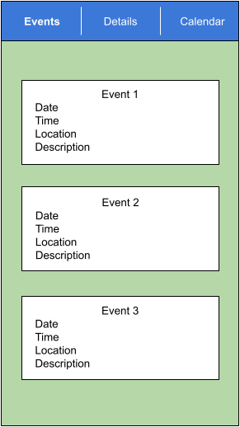
Details
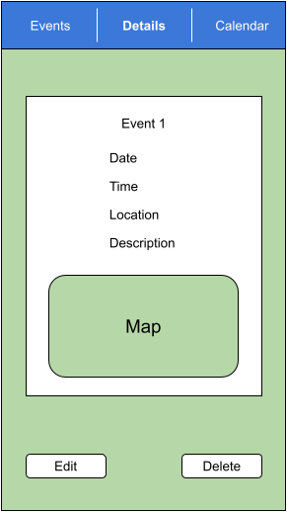

Add/Edit
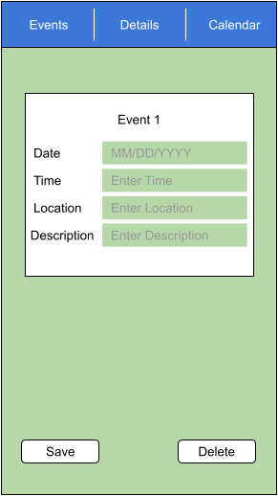

Calendar
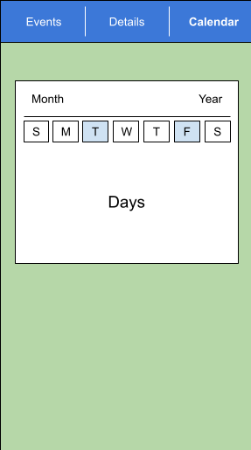
Behaviors:
The first screen will display a list of events with the soonest first. Clicking on an event will take the user to a details page where they can see the event location on a map as well as edit or delete the event.
The second screen is the expanded event view with the edit/delete options.
The third screen displays a calendar with indicators that will show at a glance on which day(s) there is an event.

Product Backlog:
- Home screen displays events
- Selecting event on home screen takes user to event’s details page.
- Home screen “add event” and Details screen “edit” button takes user to add/edit event page.
- Details page shows event location on map
- Calendar page shows which day(s) have events scheduled
- Selecting event on calendar page take user to event details

